LAB: Niche Partitioning Name: ________________________________Per:____
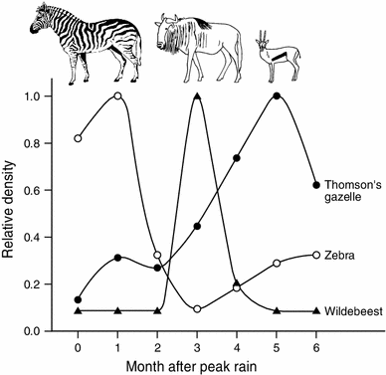
PART 3: Case Study on Niche Partitioning by Time and Grass Height
Directions: Read the Student Handout Just part 1 (pg.1)
Answer the following questions based on the figure to the right AND
from the reading.

- A) Use a RED color pencil and go over the relative density of the Zebras
in the figure.

B) What characteristics of zebras could explain why zebra densities are greatest when the P. maximum grass is tallest and most abundant after the rain?
The reason that zebra densities are greatest when the grass is
the tallest and most abundant is because, out of these three grazers, zebras get the most out of eating tall grass. Zebras’ teeth allow them to eat taller grass with stems.

The zebras can also digest grass very fast and get the nutrients they need.

- A) Use a BLUE color pencil and go over the relative density of the Wildebeasts in the figure.

- Propose a reason or reasons why the relative wildebeest density spikes when it does. Support your idea with evidence from what you know about wildebeests and P. maximum grass. (Hint: Remember that the more nutritious parts of the grass are closer to the ground. The grasses continue to grow after being grazed, and the parts that grow back are also more nutritious.)
The zebras graze first, shortening the height of the grass and eating the less nutritious parts. As the grass
grows back this allows the wildebeest to feed on the most nutritious grass without woody stems. Wildebeest
because its digestive system can extract more nutrients with a smaller amount of food than zebras.

- A) Use a GREEN color pencil and go over the relative density of the Gazelles in the figure above.

B) Gazelle are in the environment the entire time BUT WHY does the Gazelle Relative density reach its highest at 5 months
after peak rain?
This is because the wildebeest graze on the medium height grass. The gazelles need only small amounts of
food (compared to the wildebeest) as they also can extract many nutrients from a small amount of food so
gazelle population peaks AFTER wildebeest’s leave.

- The interactions between zebras, wildebeests, and Thomson’s gazelles are an example of niche partitioning.
What type of niche partitioning is this an example of? Support your answer with data from Figure 1.
Niche partitioning by TIME.
The animals feed at different times after the rain which divides the resource. The zebras arrive first (peaking in
month 1, at 1.0) The wildebeest population peaks next (from 0.1 to 1.0 from months 2 to 4) then leave. The gazelle density steadily increases (up to 1.0) as the tall grass is eaten down peaking at 5 months.

